**Arum App**

**Application Type**

* Hybrid App
  + Native app + Web App
* Operating System
  + Android
  + IOS
* Development

**3 Types of side to be built**

* Customer Side
* Admin Side
* Server Side

**Customer Side : Features**

1. Login Method – 뒷쪽에 배치하기
   1. Email
   2. Guest
   3. Facebook
2. Menu Bar
3. Category view
4. Item view
   1. Size
   2. Default Mode
   3. Option and extra
   4. Add to Favorite
   5. Add to Cart
5. Favorite View
   1. Edit control
6. My Cart
   1. Items Information
      1. Quantity
      2. Options
      3. Price
   2. Change Quantity
   3. Delete
   4. Procedure Bar with Total Price
7. Delivery Method
   1. Delivery
      1. Customer Information
         1. Name
         2. Phone Number
         3. Address with zip code
   2. Pickup
8. Payment System
9. Contact
10. Order history
    1. Re-order
11. User Setting
    1. Log- Out
12. Realtime notification in app

**Admin Side : Features**

1. Rest API
2. Orders Management
   1. Pending
   2. Delivering
   3. Complete
   4. Canceled
3. Menu Category Controller
   1. Add Category
      1. Title
      2. Description
      3. Photo
   2. Edit Category
   3. Delete Category
4. Menu Items Controller
   1. Item Add
      1. Category Selection
      2. Name
      3. Pictures
      4. Description
      5. tax
      6. price
         1. Size Control
         2. Option and extra Control
      7. Stock Displaying Control
   2. Edit Item
   3. Delete Item
5. About Us Controller
   1. Arum Information
   2. Opening Hour
   3. Delivery fee

**Active Diagram**

Customer Side

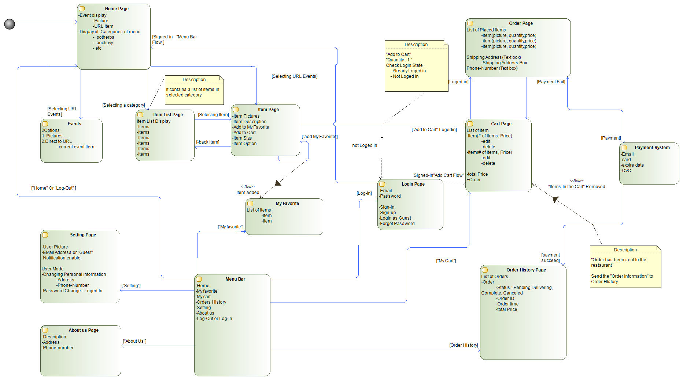

**UI Pages**

* Home
* Categories
  + Menu
* Favorites
* Cart
* Order History
  + Order-Detail
* About us
* Login-page
* Order-Process
  + Information